Module 4 Summary – Jacob Booth 221530207

Response to feedback

New upload post-submission but not a resubmission, based on feedback from module 3. I’ve leaned into developing the overall picture as I introduce new concepts. I got rid of the rephrasing and streamlined the summary as per feedback from the previous resubmission.

Module Learning Objectives
I certify that I achieved the following learning objectives for the module:
- Calculate determinants using the cofactor expansion
- Use properties of determinants (Theorem 3.1.2) to calculate determinants
- Calculate matrix inverses using adj A and det(A)
- Identify the inverse of an orthogonal matrix
- Perform LU-factorisation on a matrix and use this to solve systems of linear equations

Key Definitions and Theorems
The Cofactor Expansion
Textbook Ref | Theorem/Definition statement | Learning Notes
Determinant Calculation  for a 3×3 matrix | For a 3×3 matrix, A – the determinant is given by | Draws on the products of diagonals  Use either the shortcut formula with Sarrus’ rule or expansion by minors
Definition 3.1 Cofactors of a matrix | Assume that determinants of (n − 1) × (n − 1) matrices have been defined. Given the n × n matrix A, let  A_{ij} denote the (n − 1) × (n − 1) matrix obtained from A by deleting row i and column j. Then the (i, j)-cofactor c_{ij}(A) is the scalar defined by  c_{ij}(A) = (−1) ^{i+j} det (A_{ij})  Here (−1) ^{i+j} is called the sign of the (i, j)-position. | Dissecting sub-matrices from larger ones, carrying the idea of composition  Convenient method, just requires reference to the formula
Definition 3.2  Cofactor expansion of a matrix | Assume that determinants of (n − 1) × (n − 1) matrices have been defined. If A = [a_{ij}] is n×n define,  det A = a₁₁c₁₁(A) + a₁₂c₁₂(A) +···+ a_{1n}c_{1n}(A)  This is called the cofactor expansion of det A along row 1. | Defining the determinant from smaller pieces, recursively defining smaller matrix dets to define the det of A
Theorem 3.1.2 Determinant properties | Let A denote an n × n matrix.  - If A has a row or column of zeros, detA=0.  - If two distinct rows (or columns) of A are interchanged, the determinant of the resulting matrix is − det A.  - If a row (or column) of A is multiplied by a constant u, the determinant of the resulting matrix is u( det A).  - If two distinct rows (or columns) of A are identical, det A = 0.  - If a multiple of one row of A is added to a different row (or if a multiple of a column is added to a different column), the determinant of the resulting matrix is det A. | Unique behaviour of det, proportional scaling but adding one row to another doesn’t change det  Reduces the logic down to 5 constraints on the determinant, helpful for quick interpretation

Determinants and matrix inverses
Textbook Ref | Theorem/Definition statement | Notes
Theorem 3.2.1 Product theorem | If A and B are n×n matrices, then  det(AB) = det A det B. | Matrix product det or det of matrix product, both are the same
Theorem 3.2.2 Det relationship to inverse | An n×n matrix A is invertible if and only if det A  0. When it is invertible, we have, | Any matrix with a non-zero det is invertible
Theorem 3.2.3 Det of transpose | If A is any square matrix, det (A^{T}) = det A | Det persists across transposition
Theorem 3.2.4 Adjugate formula | If A is any square matrix, then  A(adj A) = (det A) I = (adj A) A  In particular, if det A  0, the inverse of A is given by | Multiplying A with adj(A) gives (det(A))I  Leading into the inverse formula

LU Factorisation
Textbook Ref | Theorem/Definition statement | Notes
Theorem 2.7.1 LU Theorem | If A can be lower reduced to a row-echelon matrix U, then  A=LU  where L is lower triangular and invertible and U is upper triangular and row-echelon. | Without row swaps, if matrix A can be reduced then it factors into L and U composition
LU Algorithm | Let A be an m × n matrix of rank r, and suppose that A can be lower reduced to a row-echelon matrix U . Then A = LU where the lower triangular, invertible matrix L is constructed as follows:  - If A=0, take L= I_{m} and U = 0.  - If A0, write A₁=A and let c₁ be the leading column of A₁. Use c₁ to create the first leading 1 and create zeros below it (using lower reduction). When this is completed, let A₂ denote the matrix consisting of rows 2 to m of the matrix just created.  - If A₂ 0, let c₂ be the leading column of A₂ and repeat Step 2 on A₂ to create A₃.  - Continue in this way until U is reached, where all rows below the last leading 1 consist of zeros. This will happen after r steps.  - Create L by placing c₁, c₂, ..., c_{r} at the bottom of the first r columns of I_{m}. | For each multiplier in elimination, build L from each m, recording scalar pivots in L and reduced A in U

Summarising your understanding:

Module 4 expresses the behaviour of determinants in the scope of cofactors and compositions. The module establishes cofactor expansion as the foundation for determinant calculation, a multi-faceted metric for inferring matrix behaviour in context. Module 4 compares the preservation/scaling properties of each elementary operation, the matrix adjugate and transposition are reintroduced to highlight the behaviour of the determinant’s consistency across transformed, inverted, and transposed matrices.

4.1 The Cofactor Expansion
Cofactor expansion recursively builds on sub-matrices, multiplying nested matrices by the sign (-1)^{i+j}, defined as the cofactor by Definition 3.1. Summing the entry-products with corresponding factors returns the determinant. This ties directly to the behaviour of determinants, expressed by the structural properties in Theorem 3.1.2. Similarly to how the previous module introduced inverse theorem and inverse properties as the framework for the inversion algorithm, determinant properties outline the behaviour of the determinant under elementary row operations, which is key to how LU Factorisation approaches reduction (no row swaps).
Include a worked example of applying some of the rules in Theorem 3.1.2 to simplify the calculation of a larger determinant.
The example below leverages determinant properties to perform quick mental-shortcuts for calculating the determinant. Based on condition 2, swapping two rows or columns brings det(A) to -det(A), immediately clarifying the result if det(A) is known. Condition 5 is leveraged in the second problem for clarifying that there is no change in det(A) after reduction, adding a multiple of one row/column to another doesn’t alter the determinant.
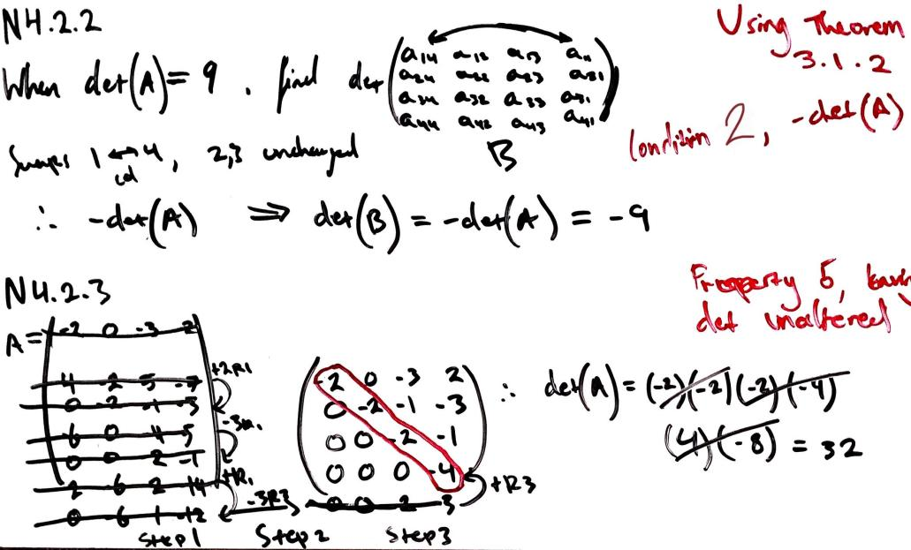
Summarily, determinant properties are leveraged for guiding the calculation, and when necessary, locally-scoped sub-matrices can be used to infer linear dependence at the global-level.
4.2 Determinants and Matrix Inverses
Building from cofactor expansion, the determinant is expressed as a sign for whether the matrix can be inverted, linking directly back to the previous module. Theorem 3.2.2 states that a matrix can only be inverted if the determinant is nonzero. Theorems 3.2.1, 3.2.3, and 3.2.4 demonstrate the behaviour of the determinant when exposed to multiplication, transposition, and the adjugate, providing tools for calculating the determinant in the problem domain, consistent with determinant properties.

Summarise Cramer’s rule and how it works. Include reference to any of the relevant definitions and theorems.
Cramer’s Rule is a method for solving a linear system given the determinant is nonzero (Theorem 3.2.2), and the coefficient matrix is square. For each x_{i} variable in the system, replace the column i with the constant vector b, giving an intermediate matrix A_{i.}. Each column of the coeff matrix is iteratively replaced with the constant vector, and each locally-calculated determinant gets divided by the original coeff determinant, returning the unknown values. Again, Theorems 3.2.1, 3.2.3, and 3.2.4 express the behaviour of determinants in context, and how the inverse, transpose, and adjugate affect it. Cramer’s Rule leverages their natural behaviour for methodically solving the unknown variables.
Tying these ideas together, Theorem 3.2.3 clarifies that transposition has no alteration on the determinant, and Theorem 3.1.2 treats row/col perspectives the same. This symmetry shows that cofactor expansion along either a row or column is valid, verified by the adjugate matrix dependence on transposing the cofactor matrix. Cramer’s rule works under this behaviour and the other unique determinant properties to solve linear systems.
4.3 LU Factorisation
Building from the modular, recursive approach of cofactor expansion, and the behaviour of determinant properties, LU factorisation ties these concepts together to transform the problem Ax = b into LUx = b. This composes the solution into two sub-matrices, whose factor is the single-matrix solution. Drawing directly from Theorem 3.1.2 (5), similarly to the previous worked example, avoiding row swaps leaves the determinant unaltered, so LU Theorem is consistent with determinant properties. The LU Algorithm works under the conditional framework established by determinant properties, using Gaussian Elimination to form a composition of a scalar matrix L, and reduced matrix U.
Write a statement on LU factorisation and when it can be applied
LU factorisation expresses the problem Ax = b as LUx = b. It’s an algorithm that can be applied to full-rank square matrices, so long as they can be reduced to an upper-triangular without any row swaps. LU Factorisation decomposes a square matrix A into the product of a lower-triangular matrix L and upper-triangular matrix U, expressing A as a factor of LU. This simplifies the problem space for solving Ax = b by reducing the matrix A into two smaller triangular systems.
Similarly to the last, module 4 encapsulates the behaviour of focus-specific properties to paint the larger picture of how an algorithm works. LU factorisation operates under the behaviour established by determinant properties in the context of inversion, products, the adjugate, and transposition, to aggregate the solution from a composition of sub-problems for full-rank matrices. Summarily, each property respects the behaviour of other properties, and establishes unique behaviour that’s consistent with each other. LU factorisation leverages the interdependence to maintain solution consistency, tying back to the idea of large contextual problems composed of smaller locally-scoped tasks.

Reflecting on the content
I found this module more intuitive than it initially appeared. I received a hit of nostalgia performing cofactor expansion and 3x3 determinant calculation, methods I’d seen and used in past classes without establishing the link until I was solving the problems. This was helpful and encouraging. I can also relate to the necessity of these concepts as a problem-solver from a computer science background. Breaking down large problems into meaningful, functional components forms the backbone of robust software engineering, in addition to the key module concepts being directly applicable to linear data analysis and software speedup. Overall, a very enjoyable unit that simplifies all the granular processes we’ve been working with weeks 1 – 4.

References

Summary, notes
[1] J. Chasnov, “LU Decomposition,” Applied Linear Algebra and Differential Equations, LibreTexts, [Online].
Available: https://math.libretexts.org/Bookshelves/Differential_Equations/Applied_Linear_Algebra_and_Differential_Equations_(Chasnov)/02:_II._Linear_Algebra/02:_Systems_of_Linear_Equations/2.05:_LU_Decomposition.
[Accessed: 05-Aug-2025].

[2] GeeksforGeeks, “LU Decomposition," Engineering Mathematics [Online].
Available: https://www.geeksforgeeks.org/engineering-mathematics/l-u-decomposition-system-linear-equations/.
[Accessed: 05-Aug-2025].

[3] D. Margalit & J. Rabinoff, “Cramer’s Rule and Adjugates,” Irvine Valley College, LibreTexts, [Online].
Available: https://math.libretexts.org/Courses/Irvine_Valley_College/Math_26%3A_Introduction_to_Linear_Algebra/02%3A_Linear_Transformations_and_Matrix_Algebra/2.06%3A_Cofactor_Expansions/2.6.02%3A_Cramer's_Rule_and_Adjugates.
[Accessed: 03-Aug-2025].

[4] D. Margalit & J. Rabinoff, “Cofactor Expansions,” Georgia Institute of Technology, LibreTexts, [Online].
Available: https://math.libretexts.org/Bookshelves/Linear_Algebra/Interactive_Linear_Algebra_(Margalit_and_Rabinoff)/04%3A_Determinants/4.02%3A_Cofactor_Expansions.
[Accessed: 03-Aug-2025].

Verification
[5] Incpt.Mobis, “Calculator Infinity,” App Store. [Online].
Available: https://apps.apple.com/us/app/calculator/id458535809.

